EE-281 Logic Design Lab

Lab #7

Pulse-Width Modulation and a simple DC Motor Controller

## Name: Ajin Sunny and Derek King

## Date of Experiment: March 30th, 2015

## Date of Completion of Report: April 6th, 2015

# **Introduction**

In this Lab we will learn about Pulse-Width Modulation by building a simple LED dimmer circuit as well as a variable speed DC motor circuit. Pulse-Width Modulation is very important to the field of electrical engineering because it is vital to power saving techniques. In this lab we will be performing two experiments; the first experiment involves us to build a simple LED dimmer using the switches on the Spartan3. Secondly, we will have to repurpose the code for part one to control the speed of a DC motor with the same switches. By using this technique, we can design circuits that use much less power than if we didn’t use Pulse-Width Modulation.

# **Experiment Description**

**Experiment 1**

In the first part of the experiment we first needed to write Verilog code for the LED dimmer circuit. The first step for implementing this design is to use Pulse-Width Modulation. Pulse-Width Modulation boils down to dividing the original clock to a more usable range, then use a counter to toggle powering the output based on how many clock cycles have passed. For part one, we used a clock divider of about 100 for the LED. Next, we used an 8-bit counter for the variable brightness control. This 8-bit number corresponds directly to the 8 switches found on the Spartan3 board. The software interprets the values on the switches (0 or 1) and converts that into an 8-bit number. The larger the number, the brighter the LED, 11111111 being the brightest and 00000001 being the dimmest with 00000000 being off.

**Experiment 2**

Below is the Verilog code that we used to implement Lab #7. Please note that a simple modification can be made to change this code into the LED dimmer code. Essentially all that needs to be changes is what variable we assign to a 1 or 0 towards the end of the top module:

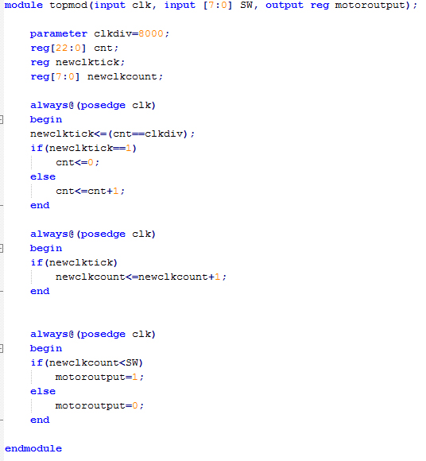

# **Results**

# **Conclusion**